PROJECT REPORT ON
“Generation of Electricity by Waste”
A Project Report Submitted in Partial Fulfillment
of the Requirements for the Degree of
Bachelor of Technology
In
DEPARTMENT OF ELECTRICAL ENGINEERING
By
Vivek Rawat (2400650200028)
Pranay Sharma (2400650200022)
Under The Guidance Of :
Mr. Dushyant Bansal
&
Mr. Abhishek Pandey

BSA COLLEGE OF ENGINEERING & TECHNOLOGY
Established & Governed Shri Agrawal Shiksha Mandal (Regd.), Mathura
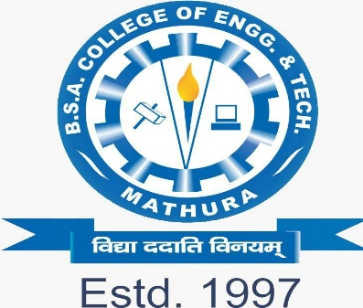
to the
DR. A.P.J. ABDUL KALAM TECHNICAL UNIVERSITY
(Formerly Uttar Pradesh Technical University,Lucknow)

DECLARATION

We VIVEK RAWAT (2400650200028) and PRANAY SHARMA (2400650200022) hereby declare that the project Reported entitled
“GENERATION OF ELECTRICITY BY WASTE” done by us under the guidance of Mr. Dushyant Bansal & Mr. Abhishek Pandey is submitted in partial fulfillment of the requirements for the award of Bachelor of Technology in Electrical Engineering.

1. Vivek Rawat (2400650200028)

2. Pranay Sharma (2400650200022)

SIGNATURE OF THE CANDIDATES
DATE: 12/11/2025

ACKNOWLEDGEMENT

Acknowledgement We would like to express our sincere gratitude to everyone who has helped and supported us in completing our project titled “Generation of Electricity by Waste.”
First and foremost, we extend our heartfelt thanks to our project guide, Mr. Dushyant Bansal & Mr. Abhishek Pandey for their valuable guidance, constant encouragement, and continuous support throughout this project. Their advice and insights have been instrumental in helping us understand the concept and successfully complete our work.
We are also thankful to the Department of Electrical Engineering and the management of B.S.A. College of Engineering & Technology, Mathura, for providing us with all the necessary facilities and resources to carry out this project effectively.
Our sincere appreciation goes to all faculty members and laboratory staff for their kind cooperation and valuable assistance during the experimental and documentation phases.
We are also grateful to our friends and classmates for their help, motivation, and constructive suggestions, which made this project a meaningful learning experience.
Finally, we express our deepest gratitude to our parents and families for their constant encouragement, moral support, and understanding throughout this project.
This project has been a wonderful learning journey, and we are thankful to everyone who contributed directly or indirectly to its successful completion.
Vivek Rawat (2400650200028)
Pranay Sharma (2400650200022)
B.S.A. College of Engineering & Technology, Mathura

ABSTRACT
Generally day by day the generation of waste is increasing every day in everywhere. The landfill sites are increasing. The generation of waste is increasing along with the increasing of the population. The pollution also increasing along with the increasing of waste generation.
In order to control the generation of waste and to reduce the pollution we are making this project in which we have been making this for the purpose of the control of waste generation and to reduce the pollution by generating electricity by heating process.
We have been collected the solid waste and separated the waste by manually under the categories of size, shape, dry, wet, etc. we avoided glass, petroleum products which effects the heating process. While heating the solid waste the heating sensors, heating panels takes observes that and converts heat energy into electrical energy and storing energy for the purpose of charging the battery which used for the supply that energy for further purpose. The capacitors used to store that energy and with the help of resistors it resists the flow of the current.

i
CONTENTS

CHAPTER PAGE
No. TITLE No.
ABSTRACT i
CONTENTS ii
LIST OF TABLES iii
LIST OF FIGURES iv
1. INTRODUCTION 1
2. LITERATURE SURVEY 8
2.1 GENERAL 8
2.2 LITERATURE REVIEW 8
3. AIM AND SCOPE OF THE EXPERIMENTAL 11
WORK
3.1 AIM 11
3.2 SCOPE OF WORK 11
4. PROPERTIES 12
4.1 PHYSICAL PROPERTIES 12
4.2 CHEMICAL PROPERTIES 13
4.3 BIOLOGICAL PROPERTIES 15
5. EXPERIMENTAL WORK 17
5.1 MATERIALS USED 17
5.2 METHODOLOGY 21
5.3 COLLECTION OF SOLID WASTE 22
5.4 SEPARATION OF WASTE 22
5.5 HEATING PROCESS 22
5.6 OUTPUT LOAD 23
5.7 DISPOSAL 23
5.8 POLLUTION FILTER PROCESS 23
5.9 CONNECTIONS 24
5.10 BLOCK DIAGRAM 26
5.11 ADVANTAGES 28
5.12 DISADVANTAGES 28
6. SUMMARY AND CONCLUSION 29

ii
LIST OF TABLES
TABLE PAGE
No. TITLE No.

5.1 OUTPUT LOAD 27
5.2 POWER GENERATION 27

iii
LIST OF FIGURES
FIGURE PAGE
No. TITLE No.
  - RATE OF GROWTH OF WORLD POPULATION 4
  - PROJECTED WASTE GENERATION BY REGION 5
  - GLOBAL WASTE COMPOSITION (%) 6
1.4 GLOBAL TREATMENT AND DISPOSAL WASTE (%) 7
5.1 MUNICIPAL SOLID WASTE 17
5.1.1 HEATING PANEL 17
5.1.2 DC MOTOR 18
5.1.3 LED BULBS 18
5.1.4 CAPACITOR 19
5.1.5 RESISTOR 19
5.1.6 HEATING SENSOR 20
5.3 COLLECTION OF SOLID WASTE 22
5.5 HEATING PROCESS 22
5.6 OUTPUT LOAD 23
5.8 POLLUTION CONTROL 23
5.9 CONNECTIONS 24
5.9.1 BEFORE STARTING 25
5.9.2 AFTER STARTING 25

iv
CHAPTER 1
INTRODUCTION
WASTE:
It is the unwanted or waste solid materials which are generated from human activities in houses, hotels, institutionals, labs, agriculture, industries or any commercial areas.
In India metro cities individually produces an average of 0.8 kg/ waste/ person daily. India has been generated municipal solid waste (MSW) estimated at 68.8 million tons per year. The average efficiency of MSW collection is 22% - 60%.
Annually the world generates 2.01 billion tonnes of MSW (Municipal Solid Waste) at least with 33% of that extremely conservatively not managed in an environmentally safe manner. Worldwide, per person waste generated per day averages 0.74 kg but ranges widely from 0.11 – 4.54 kg. Though they only account for 16% of the world’s population, developed countries generate nearly 34% (683 million tonnes) of world’s waste.
By 2050 global waste is expected to grow to 3.40 billion tonnes.
INDIA 62 million tonnes of municipal solid waste (MSW) generates each year. In this about 43 million tonnes (70%) is collected and 11.9 million tonnes (20%) is treated about 31 million tonnes (50%) is dumped in landfill sites.
TYPES OF WASTE BASED ON ORIGIN:
RESIDENTIAL:
The wastes which are refers to wastes which are from apartments, houses, dwelling, food, vegetables, plastic, books, cloths, glass, etc.
INSTITUTIONAL:
These are the wastes which are generated from the institutions like schools, collages, public buildings, etc.
COMMERCIAL:
These are the wastes refers to mainly consists of glasses, metals, markets, restaurants, hotels, stores, malls, ashes, etc.
BIO-MEDICAL:
Bio-medical wastes which are the wastes generated from hospitals, clinics, pharmacies, syrenjes, etc. It may also include from parts of animals or humans, needles, blood, etc.
MUNICIPAL:
The wastes which include treatment plant residual sludge, building wastes, dust, construction and demolition, landscaping, street cleaning, etc.

1
INDUSTRIAL:
It mainly consists of due to industrial activities such as wastes process, ashes, demolition and construction wastes, hazardous wastes, etc.
AGRICULTURAL:
The agricultural wastes are mainly consists of spoiled food grains, orchards, vegetables, vineyards, farms etc.
OPEN AREAS:
Open-areas waste that includes wastes from area such as parks, play grounds, high ways, beaches, recreational areas, etc.
TYPES OF WASTE BASED ON COMPOSITION:
GARBAGE:
It contains mainly vegetables and animal wastes which resulting from the handling, preparation, cooking and serving of food, storage. Garbage comprising these wastes contains decaying organic matter, which produces intolerable odour which attracts rats and other insects. It requires a very special care in storage, disposal and handling.
ASHES AND RESIDUES:
These are substances that remains from the burning of coal, charcoal, coke, wood and other explosive materials for heating and cooking in houses, institutions, industrial creations. Power generating plants, factories are comes under the industrial wastes. Ashes and its residues are inorganic and too in landfills.
COMBUSTIBLE AND NON-COMBUSTABLE WASTES:
These wastes are generated from institutions, households, etc., without food wastes and other highly decayable materials.
While combustible materials like paper, textile, cardboard, rubber, etc., non combustible materials are glass, tin, aluminum, ferrous and non-ferrous material.
BULKY WASTES:
It consists of large household appliances like t. v, washing machines, furniture, air conditioners, vehicle parts, wood, etc. They require a special collection mechanism.
STREET WASTES:
It includes all types of wastes that are collected from streets, parks, vacant plots, and include paper, plastic, leaves, and other vegetable matter.
CONSTRUCTION AND DEMOLITION WASTES:
These are the wastes which are generated from construction, repair and demolition of houses, buildings. It consists mainly stones, concrete, bricks, etc.

2
HAZARDOUS WASTES:
It is defined as waste of industrial, institutional or consumer origin that are hypothetically dangerous either immediately or over a period of time to human life and environment. This is due to their physical, chemical, and biological features like ignitability, corrosivity and toxicity.
SEWAGE WASTES:
These wastes square measure principally organic that square measure derived from the treatment of organic sludge separated from each treated and raw sewages. The inorganic fraction of raw biodegradable pollution like grit and eggshells is separated at the preliminary stage of treatment with pathogens and should be buried directly.
SOURCES OF WASTE:
Daily tonnes of solid waste is disposed off at many lowland sites. it's coming back from faculties, houses, industries, establishments, agriculture, etc. These lowland sites produces foul smell if it's not keep properly and not treated well. It leads to the polluting of the environment and that effects the human life, animal life, and similarly as surroundings.
RESIDENTIAL:
The major sources of solid waste square measure Residences and houses wherever folks live. Trash from these places embody food wastes, plastics, paper, glass, leather, cardboard, metals, yard wastes, ashes and special wastes like large home items like physics, tires, batteries, previous mattresses and used oil. Most homelands have garbage bins in wherever they'll throw away their solid wastes and when the bin is empty by a garbage collection firm or person for treatment.
INDUSTRIAL:
Industries square measure main contributors of solid waste. It includes lightweight and significant producing industries, construction sites, fabrication plants, canning plants, power and chemical plants. solid waste is made by industries within the variety of housework wastes, food wastes, packaging wastes, ashes, construction and demolition materials, special wastes, medical wastes similarly as alternative harmful wastes.
COMMERCIAL:
Commercial facilities and buildings also are coming back underneath solid waste sources currently a days. Hotels, markets, restaurants, go downs, stores and workplace buildings square measure thought of as industrial buildings and facilities. solid wastes like plastics, food wastes, metals, paper, glass, wood, cardboard ` materials, special wastes and alternative venturesome wastes also are generated from these industrial places.
INSTITUTIONAL:
Schools, colleges, prisons, military barracks and alternative government centers square measure Institutional centers that manufacture solid waste. Glass, rubber waste, plastics, food wastes, wood, paper, metals, cardboard materials, physics similarly as numerous venturesome wastes square measure common solid wastes obtained from these places.
3
CONSTRUCTION AND DEMOLITION:
Construction sites and demolition sites also are ends up in solid waste issues. Construction sites embody new construction sites for buildings and roads, road repair sites, building renovation sites and building demolition sites. Steel materials, concrete, wood, plastics, rubber, copper wires, dirt and glass square measure a number of wastes made in these places.
MUNICIPAL SERVICES:
The urban centers also are tributary massively to the solid waste issues in most countries currently a days. Street cleansing wastes from parks and beaches, waste treatment plants, landscaping wastes and wastes from recreational square measureas together with sludge are a number of the solid wastes caused by the municipal services.
TREATMENT PLANTS AND SITES:
Solid waste is additionally made by significant and lightweight producing plants. They embody refineries, power plants, process plants, ore dressing plants and chemicals plants. process wastes, unwanted specification product, plastics, metal components ` simply to say however a number of square measure among the wastes made by these plants.
AGRICULTURE:
Crop farms, orchards, dairies, vineyards and feedlots also are coming back underneath the sources of solid wastes. Agricultural wastes, spoiled food, chemical containers and alternative venturesome materials square measure among the wastes they manufacture.
BIOMEDICAL:
Biomedical refers to medicine instrumentation, hospitals and chemical producing companies. differing types of solid wastes square measure made in hospitals. Syringes, bandages, used gloves, drugs, paper, plastics, food wastes and chemicals square measure a number of these solid wastes. of these on top of solid wastes square measure need correct disposal as an alternative these solid wastes can cause a giant hurt to the surroundings and other people in these facilities.
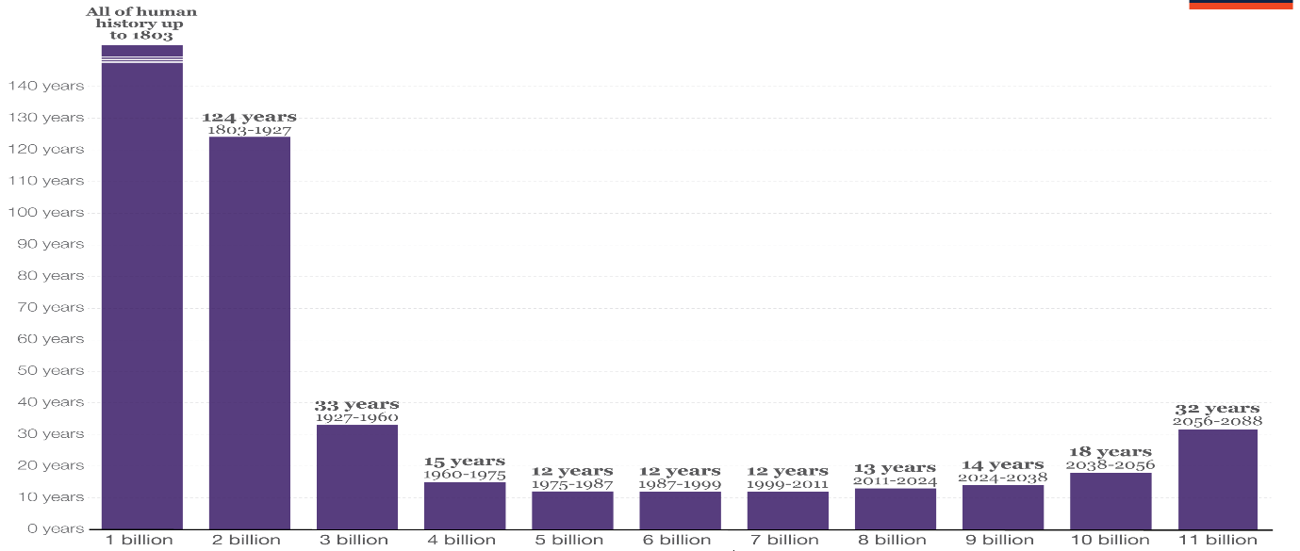

4
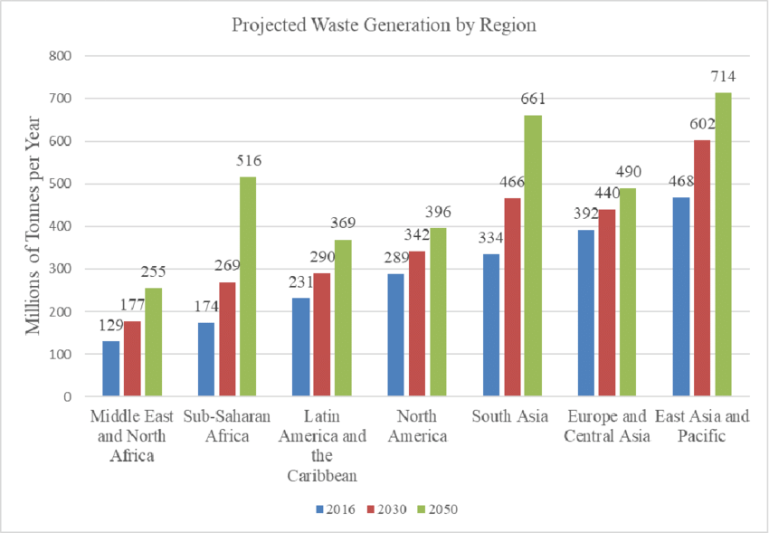

Every year, the world generates a pair of 2.01 billion tonnes of municipal solid waste, with a minimum of 33% of that—extremely conservatively—not managed in AN environmentally safe manner. Worldwide, waste generated per person per day averages zero.74 weight unit however ranges wide, from 0.11 to 4.54 kilograms. They solely account for sixteen % of the world’s population, high-income countries generate concerning 34%, or 683 million tonnes, of the world’s waste.
When trying forward, world waste is anticipated to grow to three.40 billion tonnes by 2050, quite double growth over identical amount. Overall, there's a correlation between waste generation and financial gain level. Daily per capita waste generation in high-income countries is projected to extend by 19% by 2050, compared to low- and middle-income countries wherever it's expected to extend by close to four hundredth or a lot of. Waste generation at first decreases at rock bottom financial gain levels and so will increase at a quicker rate for progressive financial gain changes at low financial gain levels than at high financial gain levels. the whole amount of waste generated in low-income countries is anticipated to extend by quite 3 times by 2050. The East Asia and Pacific region is generating most of the world’s ` waste, at twenty three %, and also the geographical area and geographical region region is manufacturing the smallest amount in absolute terms, at six %. However, the quickest growing regions area unit geographic area, South Asia, and also the geographical area and geographical region, where, by 2050, total waste generation is anticipated to quite triple, double, and double severally. In these regions, quite half waste is presently brazenly drop, and also the trajectories of waste growth can have large implications for the surroundings, health, and prosperity, so requiring pressing action.

5
Waste assortment could be a crucial step in managing waste, nonetheless rates vary for the most part by financial gain levels, with upper-middle- and high-income countries providing nearly universal waste assortment. Low-income countries collect concerning 48 % of waste in cities, however this proportion drops drastically to 26 % outside of urban areas. Across regions, geographic area collects concerning 44 % of waste whereas Europe and Central Asia and North America collect a minimum of 90% of waste.
Waste composition differs across financial gain levels, reflective varied patterns of consumption. High-income countries generate comparatively less food and inexperienced waste, at 32% of total waste, and generate a lot of dry waste that might be recycled, together with plastic, paper, cardboard, metal, and glass, that account for 51% of waste. Middle- and low-income countries generate 53% and 57% food and inexperienced waste, severally, with the fraction of organic waste increasing as economic development levels decrease. In low-income countries, materials that might be recycled account for under 20% of the waste stream. Across regions, there's not abundant selection inside waste streams on the far side those aligned with financial gain. All regions generate concerning 50% or a lot of organic waste, on average, aside from Europe and Central Asia and North America, that generate higher parts of dry waste
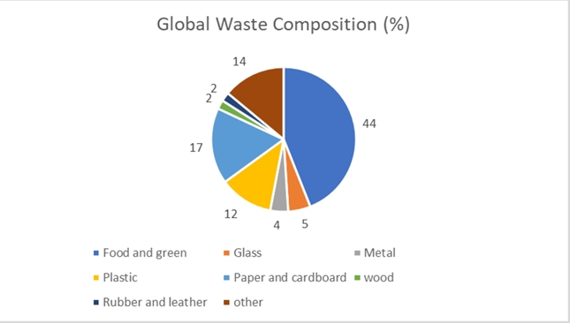
It is a frequent thought that technology is that the resolution to the matter of unmanaged and increasing waste. Technology isn't a nostrum and is typically just one issue to contemplate once managing solid waste. Countries that advance from open merchandising and different rudimentary waste management ways area unit a lot of seemingly to succeed after they choose regionally acceptable solutions. Globally, most waste is presently drop or disposed of in some sort of a lowland. Some 37% of waste is disposed of in some sort of a lowland, eight % of that is disposed of in sanitary lowlands with landfill gas assortment systems. Open merchandising accounts for concerning 31% of waste, nineteen % is recovered through exercise and composting, and eleven % is incinerated for final disposal. Adequate waste disposal or treatment, like controlled landfills or a lot of strictly operated facilities, is sort of completely the
6
domain of high- and upper-middle income countries. Lower-income countries typically accept open dumping; 93% of waste is drop in low-income countries and solely a pair of % in high income countries. 3 regions brazenly dump quite half their waste—the geographical ` area and geographical region, geographic area, and South Asia. Upper-middle income countries have the very best share of waste in landfills, at 54%. This rate decreases in high-income countries to thirty-nine %, with diversion of 36% of waste to exercise and composting and 22% to combustion. combustion is employed primarily in high-capacity, high-income, and land-constrained countries.
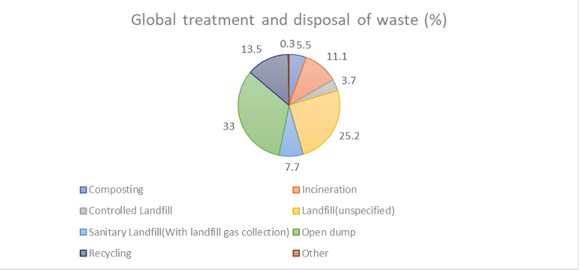
Based on the degree of waste generated, its composition, and the way it's managed, it's calculable that 1.6 billion tonnes of greenhouse gas (CO2) equivalent gas emissions were generated from solid waste treatment and disposal in 2016, or five % of world emissions. this can be driven primarily by getting rid of waste in open dumps and lowlands while not landfill gas assortment systems. garbage accounts for nearly five hundredth of emissions. Solid waste–related emissions area unit anticipated to extend to a pair of.38 billion tonnes of CO2-equivalent each year by 2050 if no enhancements area unit created within the sector.
In most countries, solid waste management operations ar usually an area responsibility, and nearly seventy p.c of states have established establishments with responsibility for policy development and restrictive oversight within the waste sector. ` concerning simple fraction of states have created targeted legislation and rules for solid waste management, although social control varies drastically. Direct central government involvement in waste service provision, apart from restrictive oversight or financial transfers, is unusual, with concerning seventy p.c of waste services being 11 overseen directly by native public entities. a minimum of half services, from primary waste assortment through treatment and disposal, ar operated by public entities.

7
CHAPTER-2
2.1 GENERAL
This is made and planned to do by reviewing some of the literature. The importance of reviewing literature is to analyze the research work related to this study.
2.2 LITERATURE REVIEW
This literature review will be the mechanism by which research is viewed as a cumulative process. That makes it an integral component of the scientific process. Abstracts of related literatures have been detailed below.
Ahmmad and Haque (2014) suggested that solid waste created within the {Dhaka|national capital} town of Bangladesh are often used as a renewable energy supply. By adopting gas assortment method rather than furnace method additional energy are often extracted from waste.
C.F.King and L.C.Stuckenbruck (1976) worked on Solid Waste As another for Power and warmth Generation. This paper shows that the theoretical potential of energy from municipal solid waste is adequate to 5 % of the desired fuel by all the utilities within the us; the energy that is made is adequate to twenty eighth of the oil made for delivery through the pipeline. within the paper, this standing of systems ` which is able to recover energy from solid waste is reviewed, The systems square measure grouping into four classes that square measure direct utilization of unprepared waste; utilization of separated waste; pyrolysis; and biomass conversion. The doable cases of future development and enlargement square measure examined with a read toward choice and implementation of a system and therefore the selling and salable energy recovered.
Changkook Ryu and Donghoon Shin (2012) worked on Current standing and problems on Combined Heat and Power from Municipal Solid Waste in Asian nation. This study states an outline of CHP by MSW to energy plants in Asian nation and mentioned the issuses associated with energy potency improvement. The necessary energy resource for combined heat and power production is Municipal solid waste. Generation of power in the WtE CHP plants was projected to be solely three.65% of the thermal input and warmth production was sixty.79%. The R1 potency for the CHP plants compared to it in europe was similar and better for warmth solely plants.
In 2010, around half the 51 massive WTE plants were CHP, whereas others made heat. up of power generation potency for brand spanking new power plants manufacturing steam at pressure on top of the present level of 20-30 bar is needed. Transboundary centralization of WtE plants between neighboring native authorities is important for warmth utilization since several existing small-scale plants don't recover heat.
D.L.Wise and R.G. Kispertmics (1981) of bioconversion of municipal solid waste (MSW) to liquid and vapourish fuels was conducted, supported data within the literature and by personal communication with developers of the processes. to produce a typical basis, processes were graded by conniving the tipping fee required to method the MSW victimization assumed costs for product fuels likewise as capital and operative expenses.
8
No quantitative live of the comparative benefits between liquid and vapourish fuels was created.The outline results of this economic analysis were: read at intervals Article due to the assumptions that had to be created, the derived tipping fees aren't absolute however could also be thought to be “figures of merit”.
Dong Liang Zhang et al (2015) has studied Key Challenges and Opportunities of Waste to Energy in China. the most important developing country within the world is china, experiencing each economic maturation and largescale urbanization. The things in china have result in waste disposal issues, and therefore the have to be compelled to establish energy sources. A supply of renewable energy, Waste to Energy conversion proceses square measure expected to play AN more and more importance role in china’s rectifiable management of municipal solid waste. The determination of this analysis is to analyze the key issues and opportunities related to WTE, to produce recommendations for the government.This paper starts by explaining china’s current MSW management scenario and finding out its waste disposal issues. the key challenges allied with china’s WTE incinerations square measure then mentioned from economic, environmental and social points of read. It embrace the high prices related to construction vital facilities, the status of facilities to corrosion, the lower heating worth of china’s MSW, air waste product emissions and particularly public opposition to WTE burning.
Ismael Salim Lopez (2017) Studied concerning the Energy Recovery of the Reject Materials from Municipal Solid Waste Treatment Plants in European country. In 2012, 21.2 million metric plenty of municipal solid waste was collected in European country (MAGRAMA two014), within which eighty fifth of solid waste corresponds to mixed waste. Then this can be treated in several plants with the aim of ill materials for his or her later use and therefore the transformation of the perishable organic fraction into compost and biogas. However, the whole quantity of fabric processed in these plants, 42.2% is rejected. In 2012, only 13.57% of the whole quantity of the rejected material was processed in these plants. the remainder was deposited in landfills. Therefore, a major quantity of the fabric is rejected the aim of this work is to research, on the one hand, the P.E. recovery of the fabric rejected from the ` municipal solid waste plants in energy recovery plants, by finding out the energy potency of the present plants. On the opposite hand, it'll additionally compare completely different energy valorization technologies so as to research the necessity for brand spanking new Waste-to-Energy plants to require advantage of all the rejected biofuel material generated in European country.
Murphy,J.D and Mckeogh,E (2004) has studied regarding Technical, economic and environmental analysis of energy production from municipal solid waste. during this study technologies area unit examined that manufacture energy from municipal solid waste area unit incineration, chemical process, generation of biogas, usage during a combined heat and powerhouse, generation of biogas and alter to move fuel.
Stephen Burnley et al (2011) has studied regarding Energy implications of the thermal recovery of perishable municipal waste materials within the uk. Waste ` management plans and legislation in several developed countries entail a discount within the amount of perishable waste landfilled. Anaerobic digestion, combustion and chemical change area unit choices for managing perishable waste whereas generating renewable energy. However, little analysis has been administrated to ascertain the energy balance of the gathering, preparation and energy recovery processes for various kinds of wastes. while not this data, it's not possible to see the optimum methodology for managing a specific waste to recover renewable energy.
9

During this study, energy balances were administrated for the thermal process of waste, garden waste, wood, paper and therefore the non-recyclable fraction of municipal waste. There was additionally very little reliable data on the performance and potency of anaerobic digestion and chemical change facilities for waste. However, we have a tendency to known a scarcity of reliable data on the energy consumed in grouping individual wastes and getting ready the wastes for thermal process.
Suraiya Yasmin and Md Imranur Rahman (2017), This study review of Solid Waste Management follow in capital of Bangladesh town. Waste management could be a stimulating task because of population is increasing and kind of waste is dynamical. Waste management follow desires concern for its generation increasing and inadequate follow. The waste generation rate is increasing because of increasing rate of population in capital of Bangladesh town wherever a reparable waste follow is needed to develop. This criticism can summaries the recent year’s state of waste generation and management practices. The review reveals that the uncollected wastes area unit drop in open areas and streets that clog the system making serious hazards, environmental degradation and health risks within the town. Awareness on varied aspects of waste management will facilitate reduce waste generation and improve waste management method.
Wajeeha Anum Qazi and Mahound F M Abushammala (2020) has studied multi criteria call analysis of waste to energy technologies. This arcticle shows that the fast increase within the generation of solid waste and rising demand for energy and preservation of fossil fuels worldwide caused a rise within the quality of waste to energy technologies because the answer for waste management issues and energy ` demands. WTE technologies convert the waste to energy and minimize the number of waste sent to landfills, that additionally reduces negative impact on close surroundings. This chapter presents the method and specific aspects of WTE technologies together with their blessings and downsides. It additionally discusses the vital criteria concerned to pick out and guarantee economical operation of WTE technology. This chapter proves that the waste and method should closely match to realize correct conversion of waste and higher potency of a WTE technology. in style multi-criteria decision-making techniques square measure mentioned during this chapter, as they need the aptitude to resolve a fancy call downside of choosing the correct WTE technology that involves several factors.
Wei Gu and Di Liu et al (2021) worked on Energy recovery potential from combustion victimisation municipal solid waste supported multi-scenario analysis in national capital. The rapid climb of municipal solid waste (MSW) generation, waste-to-energy (WTE) combustion has gained quality thanks to its potential for electricity generation and fleetly reducing the quantity and mass of MSW. This paper makes an attempt to require into consideration the various levels of MSW supply separation likewise because the impact of various MSW compositions on energy recovery potential from combustion. we have a tendency to assume that the MSW management level in national capital in 2025 can reach that of developed countries (e.g., Australia), that have pr expertise and mature MSW management systems. They established six eventualities and differentiate them by the composition and lower heating values (LHV) of MSW, thought of with and while not utilization and supply separation to variable degrees. the expected quantity of MSW generation in 2025 is eleven,505,400 tons with a pair of.255% mean absolute proportion error (MAPE).
10
CHAPTER-3
AIM AND SCOPE OF THE EXPERIMENTAL WORK
3.1 AIM:
The main aim of doing this project is to generate electricity from the municipal solid waste by reducing the waste before decomposing in the landfill sites by controlling the pollution by using filter control process and by reducing biogas (Methane gas) without decomposing in landfills.
3.2 SCOPE OF WORK:
To generate electricity from municipal solid waste in order to reduce the wastes by heating process and by reducing the pollution by using the pollution control filter. To ` convert the heat energy into mechanical energy by using the heating sensor and heating panel.

11
CHAPTER-4
PROPERTIES
4.1 PHYSICAL PROPERTIES:
PHYSICAL CHARACTERISTICS
Information and data on the physical properties of solid wastes are necessary for the selection and operation of equipment and for the analysis and magnificence of disposal facilities. the following physical characteristics are to be studied intimately.
DENSITY:
The crucial have faith in the design of a solid waste management system is density of waste, i.e., its mass per unit volume(kg/m), e.g., the design of healthful landfills, storage, styles of assortment and transport vehicles, etc. to clarify that academic degree economical operation of a lowland demands compaction of wastes to optimum density. ancient compaction instrumentality will do reduction seventy fifth in volume of wastes , which will increase academic degree initial density of 1 hundred kg/m3 to four hundred kg/m3. in numerous words, a vehicle that's aggregation waste can haul fourfold the load of waste in its compacted state than once it's uncompacted. necessary changes in density occur impromptu as a result of the waste moves from offer to disposal, due to scavenging, handling, wetting and drying by the weather, vibration at intervals the assortment vehicle and decomposition.
MOISTURE CONTENT:
The relation of the load of water to the complete wet weight of the waste is made public as condition content. condition is directly proportional the load of solid wastes, and thereby, the value of assortment and transport. condition content is also an important determinant at intervals the economic risk of waste treatment by burning, as a result of wet waste consumes energy for evaporation of water and in raising the temperature of water vapor. at intervals the most, wastes have to be compelled to be insulated from downfall or completely different extraneous water. A typical vary of condition content is twenty to ordinal, representing the extremes of wastes in academic degree arid climate and at intervals the wet season of a part of high precipitation. However, values larger than ordinal are not uncommon. climate apart, condition content is sometimes higher in low-income countries as a result of the higher proportion of food and yard waste.
SIZE OF WASTE CONSTITUENTS:
The size distribution of waste ingredients at intervals the waste stream is significant as a result of its consequence at intervals the design of mechanical separators and device and waste treatment methodology. This varies wide and whereas coming up with a system, correct analysis of the waste characteristics has to be compelled to be distributed.

12
CALORIFIC VALUE:
The amount of heat generated from combustion of a unit weight of a substance is termed hot value, expressed as kcal/kg. measuring system is used to figure out the recent value through Associate in Nursing experiment throughout that the heat generated at a relentless temperature 25OC from the combustion of dry sample is measured. The essential physical properties that are useful to research of wastes disposed at landfills are:
FIELD CAPACITY:
The total amount of condition which could be preserved in a {very} very waste sample subject to attraction pull is termed volume unit of municipal solid waste.IT is ` necessary live as a result of leachate that forms by excess water of volume unit and additionally the key draw back for landfills is leachate. volume unit changes with the degree of applied pressure and additionally the state of decomposition of the wastes.
PERMEABILITY OF COMPACTED WASTES:
The necessary property of solid waste is hydraulic natural phenomenon of compacted wastes as a result of it governs the movement of liquids and gasses in lowland. consistence depends on enlightened the alternative properties of the solid materials like pore size distribution, expanse and consistence. consistence is made public as a result of the number of voids per unit total volume of cloth. The consistence of municipal solid waste differs typically from 0.40 to 0.67 betting on the compaction and composition of the waste.
COMPRESSIBILITY:
It is the degree of physical changes of the suspended solids or filter cake once subjected to pressure.
4.2 Chemical Characteristics:
Knowledge of the classification of chemical compounds and their characteristics is important to correct understanding of the behaviour of waste, because it moves through the waste management system. The merchandise that area unit rotten and heating values area unit 2 chemical characteristics examples. Before victimisation solid wastes as fuel or the other purpose, we have a tendency to should understand their chemical characteristics, as well as the subsequent.
Chemical: Chemical characteristics embody pH, Nitrogen, Phosphorus and metallic element (N-P-K), total Carbon, C/N ratio, hot worth.
Bio-Chemical: Bio-Chemical characteristics embody carbohydrates, proteins, fibre, and perishable issue.
Toxic: Toxicity characteristics embody serious metals, pesticides, pesticides, Toxicity check for Leachates (TCLP), etc.

13
PH:
A 5-gm portion of the pulverised sample is mixed with fifty mil of H2O by stirring so pH is measured by a pH meter. The pH of contemporary solid waste is generally around seven. throughout decomposition it tends to become acidic Associate in Nursing stabilised solid waste has a basic pH.
Organic Content:
A 10-gm portion of the dried ground sample is placed in a very oxide dish and slowly heated in an electrical chamber to 700 C for thirty min. The residue is weighed and therefore the loss of weight represents the organic content and is expressed as % by weight. The information of organic content helps assess the practicability of biological processing-composting and anaerobic digestion.
Carbon Content:
The carbon is decided by victimisation the New Zealand formula within which the % organic matter is split by one.
Nitrogen Content:
From Kjeldahl technique, total element is obtained and therefore the element and metallic element area unit calculable by victimisation phosphomolybdic and flame measuring technique. In composting element, element and caustic potash values area unit necessary.
Toxicity:
Heavy metals, pesticides, pesticides etc area unit toxicity characteristics. serious metals area unit gift in municipal solid waste because of the waste from tiny scale industries. As a number of the serious metals leach out, testing for serious metals is commonly dispensed. If the waste is suspected to be cyanogenetic in nature then toxicity Characteristics natural process Procedure check is invariably dispensed.
Natural fibres:
Natural fibres embody the natural compounds, cellulose, and lignin, that area unit proof against biodegradation. Natural fibres area unit found in paper and paper merchandise and in food and yard waste. The larger chemical compound of aldohexose is polyose whereas polymer consists of a gaggle of monomers of that aromatic hydrocarbon is that the primary member. Paper, cotton and wood merchandise contain 100%, ninety fifth and four-hundredth of polyose severally. solid waste containing high proportion of paper and wood merchandise, area unit appropriate for combustion. The hot values of overdried paper merchandise area unit within the vary 12000 – 18000 kcal/kg and of wood regarding 20000 kcal/kg, that compare with 44200 kcal/kg for heating oil.

14
Synthetic organic material (Plastics):
Plastics area unit extremely proof against biodegradation and objectionable and of special concern in solid waste management. Therefore, the increasing attention being paid to the employment of plastics to scale back the proportion of this waste element at disposal sites. Plastics have a high heating worth, about 32,000 kJ/kg, that build them terribly appropriate for combustion. However one ought to note that polyvinyl resin, when burnt, produces hydrocarbon and acid gas. The latter will increase corrosion within the combustion system and is chargeable for acid precipitation.
Non-combustibles:
Non-combustible includes glass, ceramics, metals, dirt and ashes, and accounts for twelve – twenty fifth of dry solids.
Ultimate analysis:
It is outlined because the analysis of waste to see the proportion of carbon, hydrogen, oxygen, element and sulphur, and supreme analysis is finished to perform mass balance calculation for a chemical or thermal method. Besides, it's necessary to see ash fraction attributable to its doubtless harmful environmental effects, led to by the presence of cyanogenetic metals like atomic number 48, chromium, mercury, ` nickel, lead, tin and metal. One ought to note that alternative metals can also be gift however they're non-toxic.
Proximate analysis:
Proximate analysis is vital in evaluating the combustion properties of wastes or a waste or refuse derived fuel. The fractions of interest are:
• moisture content, that adds weight to the waste while not increasing its heating worth, and therefore the evaporation of water reduces the warmth discharged from the fuel.
• ash, that adds weight while not generating any heat throughout combustion.
• volatile matter, i.e., that portion of the waste that's born-again to gases before and through combustion.
• fixed carbon, that represents the carbon remaining on the surface grates as charcoal. A waste or fuel with a high proportion of fastened carbon needs a extended retention time on the chamber grates to attain complete combustion than a waste or fuel with a coffee proportion of fastened carbon.
4.3 BIOLOGICAL PROPERTIES:
The organic elements are often born-again biologically to gases and comparatively inert organic and inorganic solids is that the most significant biological characteristics of the organic fraction of MSW. The assembly of odours and therefore the generation of flies also are associated with the perishable nature of the organic materials found in MSW.
Excluding plastic, rubber and animal skin elements, the organic fraction of most MSW is often classified as follows:
15
• soluble constituents like sugars, starches, amino acids, and numerous organic acids.
• Hemicelluloses, a condensation product of five- and six-carbon sugars.
• polyose, a condensation product of the six-carbon sugar aldohexose.
• Fats, oils, and waxes that area unit esters of alcohols and long-chain fatty acids.
• Lignin, a chemical compound material containing aromatic rings with methoxy teams, the precise chemical nature of that continues to be not proverbial.
• Lignocelluloses, a mixture of polymer and polyose.
• Proteins, that square measure composed of chains of amino acids.
Volatile solids content, determined by ignition at 550 CC, is usually used as a live of the biodegradability of the organic fraction of MSW. the employment of VS in describing the biodegradability of the organic fraction of MSW is dishonest, as a number of the organic constituents of MSW square measure extremely volatile however low in biodegradability.

16
CHAPTER-5
5.1 MATERIALS USED:
MUNICIPAL SOLID WASTE:
It is the first and fore most material which is the important for this project. In this only collecting the municipal solid waste which consists of papers, cardboard, plastic, wood, etc.
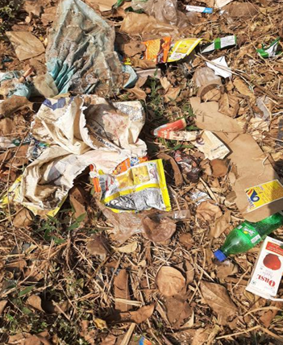
FIG 5.1: Municipal Waste
HEATING PANEL:
Heating panel is the material which is used for converting the heat energy into electrical energy. It works by allowing heat, to generating flow of electricity. Simply this heating panel converts heating or light energy into electricity or electrical energy.
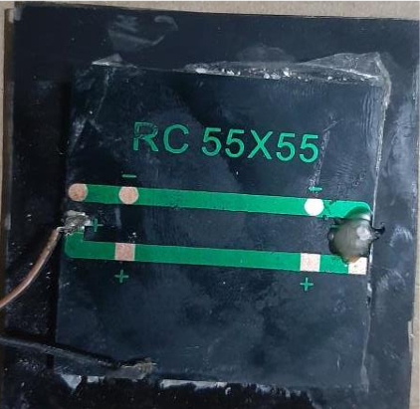
Fig 5.1.1: Heating panel (5v)
17
DC MOTOR:
It is the device that converts the electricity into the mechanical work. It works on the physicist Law, that states that “the current carrying conductor placed in a very magnetic and force field expertise a force” which force is named the force.
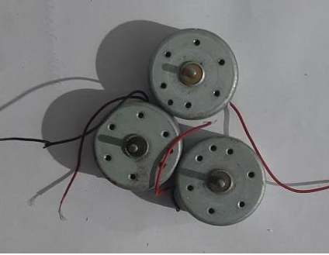
Fig 5.1.2: DC motor(5v)
LED BULB:
When an acceptable current is applied to the leads, negatrons area unit ready to recombine with electron holes among the device, cathartic energy within the kind of photons. This impact is termed electro lumine scence.
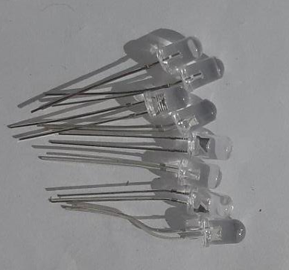
Fig 5.1.3: Led bulbs (5v)

18
CAPACITOR:
It is a component which has the ability to store energy in the form of an electrical charge producing a potential like a small rechargeable battery.
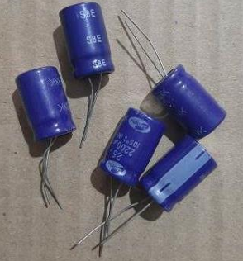
Fig 5.1.4: Capacitor (2.5v)
RESISTOR:
It is used to reduce the flow of current, to divide voltages. It controls the flow of the current and resits it’s the flow of the current.
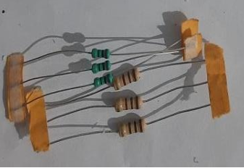
Fig 5.1.5: Resistor

19
HEATING SENSOR:
It is used to convert the heat energy into electrical energy. When this is heated by the heating it takes that heat and converts that heat energy into electrical energy.
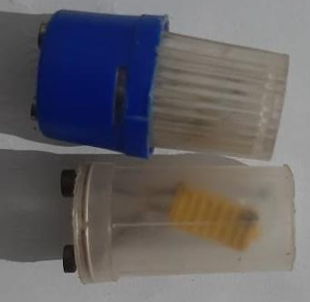
Fig 5.1.6: Heating Sensor

20
5.2 METHODOLOGY:
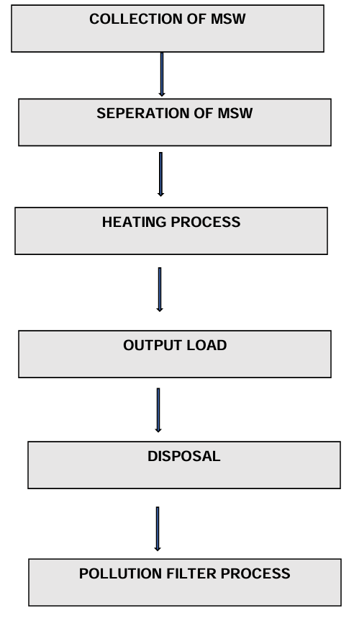
21
5.3 COLLECTION OF MUNICIPAL SOLID WASTE:
MSW have been collected from households, surroundings and various places before that solid waste are decomposing in the landfills which are useful for our project.
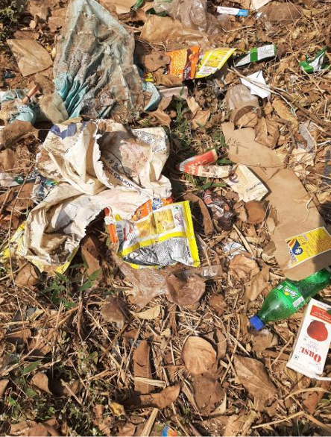
Fig 5.3 Collection of Solid Waste
5.4 SEPERATION OF MUNICIPAL SOLID WASTE:
The collected MSW has been separated by manually under the categories based on size, shape, weight, dry, wet, etc. The separation should be taken very carefully and avoid any toxic materials like medicines, injections, glass, etc which will be a problem for the further process i.e. heating process.
5.5 HEATING PROCESS:
The separated solid waste which is collected for the project has been taken in the heating box for the heating process while heating the solid waste care should be taken the heating sensor is connected while heating process is going on the heating sensor and the heating panel takes the heat and converts that heat energy into electrical energy. The heating sensors, heating panels are used as like solar panels. It is the first and foremost process which is the main process in which the heat energy is converted into electrical energy. While doing this process care should be taken. The energy from this process taken by the heating panels and transfers that energy into the rechargeable battery through the circuits which helps to resists the flow of the current. The capacitors used to store the energy.
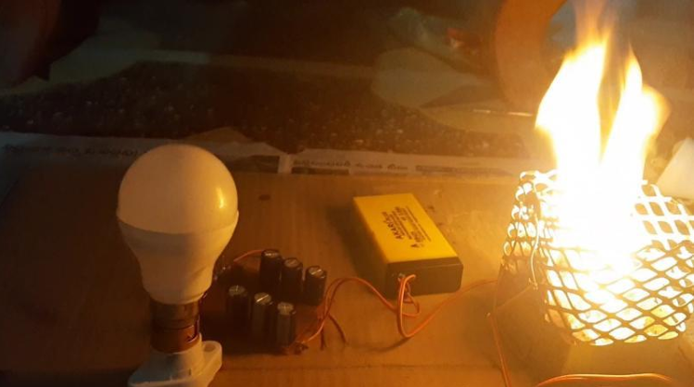
FIG 5.5 Heating Process

22
5.6 OUTPUT LOAD:
The energy which is stored in the battery is transferred to the externally which is used as the output load.
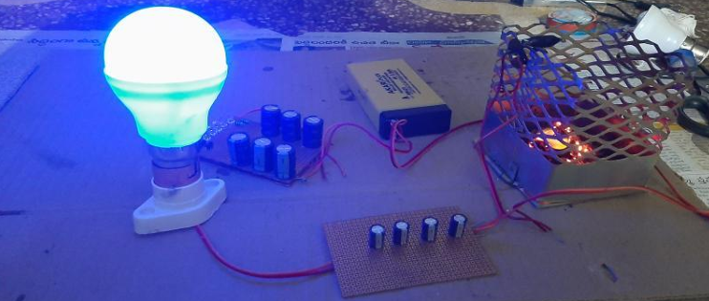
Fig 5.6: Output Load 5.7
DISPOSAL:
The remaining residue which is left in the process in the form as ash is disposed and if it is used for further process then is used and the remaining waste like ash is disposed outside.
5.8 POLLUTION FILTER PROCESS:
The smoke which is coming from the heating box is send to the filter control which used to control the pollution.
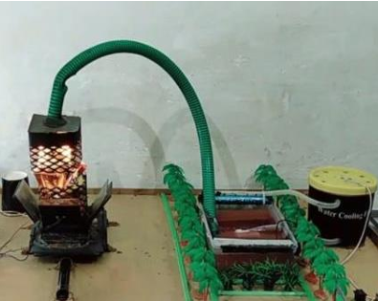
Fig 5.8 Pollution Control Process

23
5.9 CONNECTIONS:
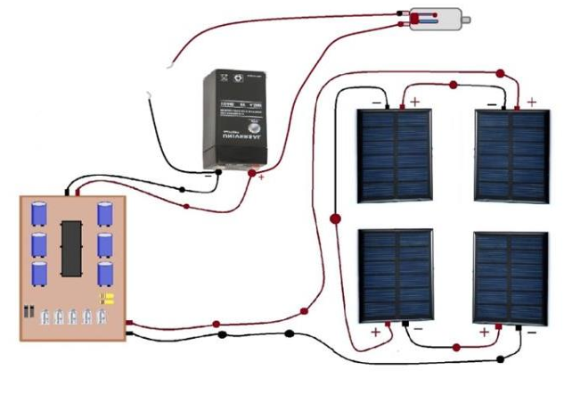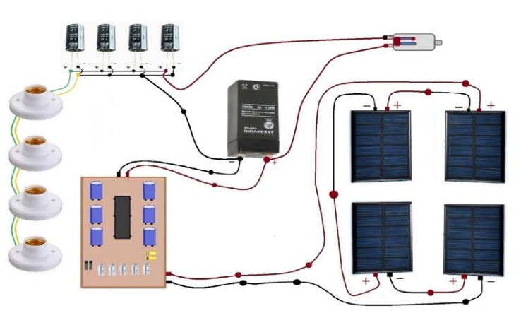

24
BEFORE STARTING:
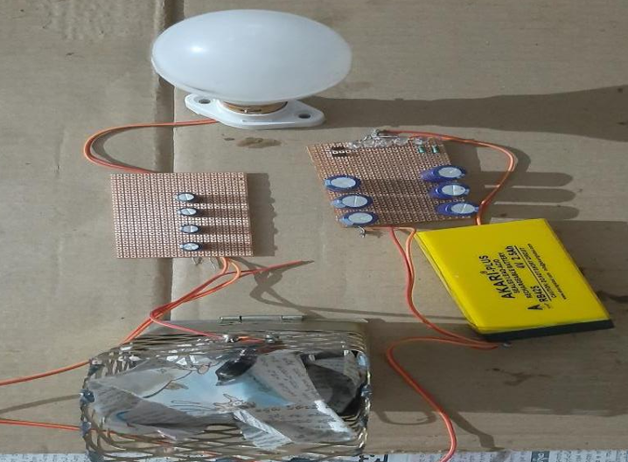
FIG 5.9.1 Before Starting

AFTER STARTING:
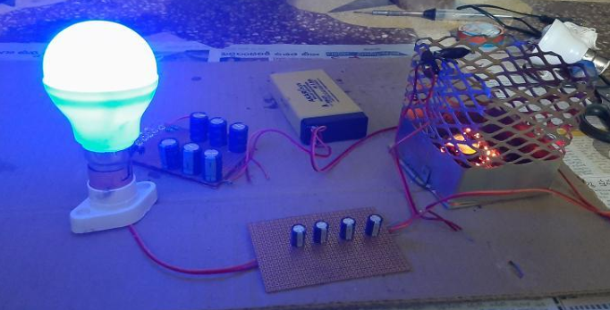
FIG 5.9.2 After Starting

25
5.10 BLOCK DIAGRAM:
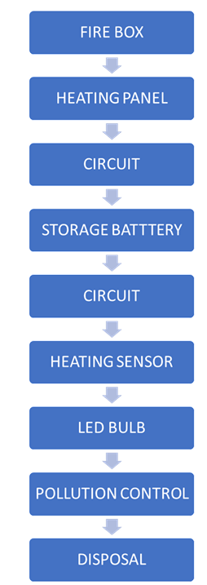

26
5.1 Output Load

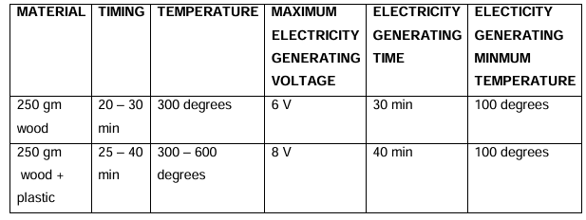

5.1.1 POWER GENRATION

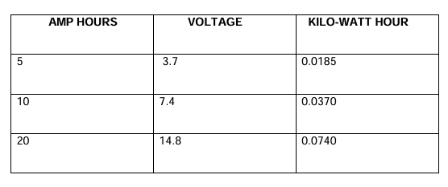

27
5.11 ADVANTAGES:
• We can generate electricity by direct wood and waste materials
• We can generate electricity by plastic
• We can generate electricity by burning heat.
• We can generate electricity anywhere.
• We can generate electricity with generator.

5.12 DISADVANTAGES:
• We can only generated Electricity when plastic and waste burning.
• We cannot control 100% pollution.
• We cannot burn petroleum products

28
CHAPTER-6
SUMMARY AND CONCLUSION
6.1 GENERAL:
In this chapter, the summary and conclusion of this project about the generation of electricity from solid waste by heating process has been discussed.
6.2 Summary:
In this project the generation of electricity from the solid waste by the heating process. These materials have been used for the generation of electricity by heating process by controlling the pollution by using the pollution filter. The filter has been setup in order to control the pollution while heating process has been going on. The results obtained after doing this process is analysed and its efficiency for generating electricity.
6.3CONCLUSION:
In the world the solid waste generation is increasing day by day everywhere.
In order to control that solid waste generation by controlling the pollution for the purpose of generation of electricity. In this project we show that how to generate electricity from solid waste successfully by the process of heating. We cannot control the pollution completely but we can control the pollution for up to some extent. We can generate electricity from solid waste by the process of heating and we can supply that electricity for the use.
We are reducing the solid waste and biogas without decomposing in the landfill sites. Thus, we can say that we completely show that generation of electricity from solid waste by the heating process.

29

